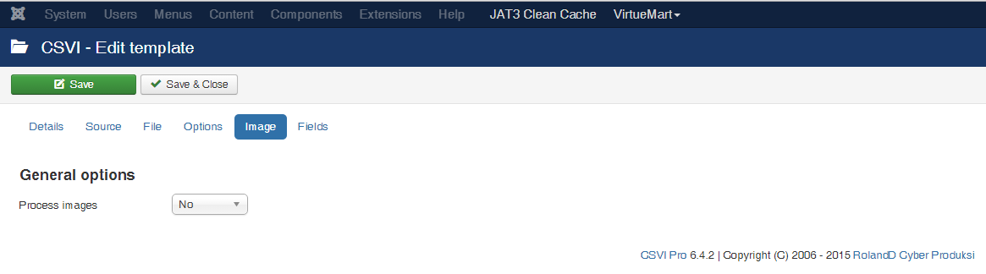
(In version 5 i could point out that the import was based on product_sku. I can’t find that option in version 6.4.2.)
5. Before I do the import you can see that I have 3585 products in my Database and the highest product_id is 5867.


