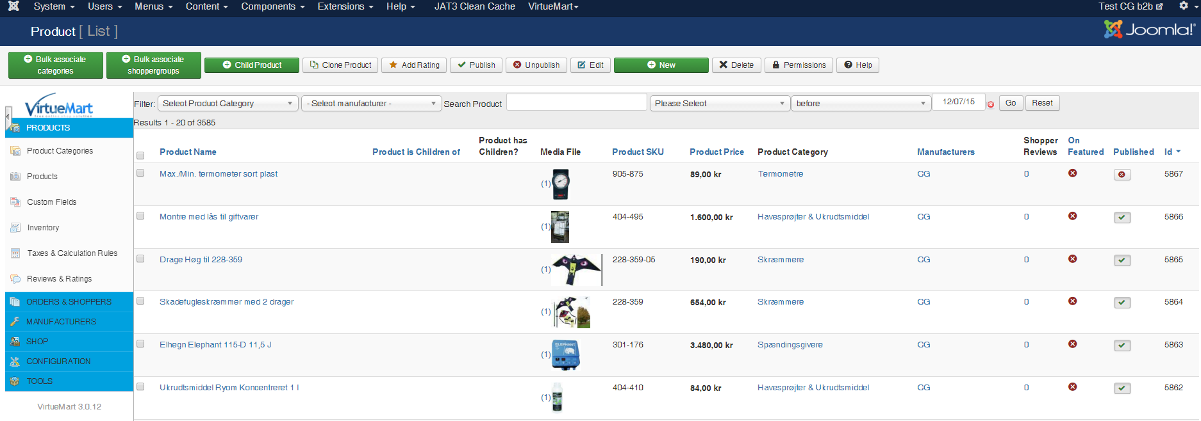
6. Importing my tab separated file.


