First I try to import the file in the following image and does not allow me to. ( The custom field Capital Contract is already created earlier) :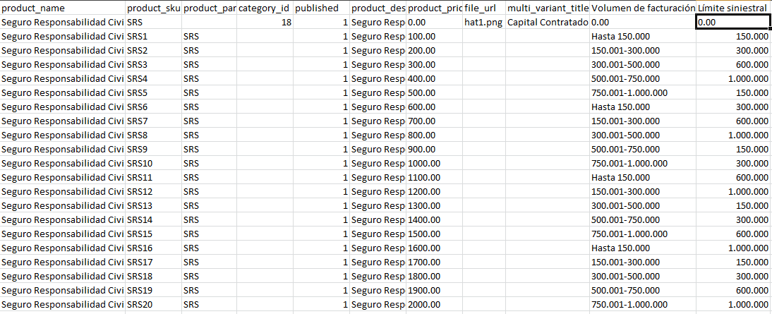
I managed to fix first importing a file with the parent product , updating the fields available import and importing a file with derivatives. I would make the full import by one csv file.
In addition to importing everything it seems to work correctly as shown in the following figure:
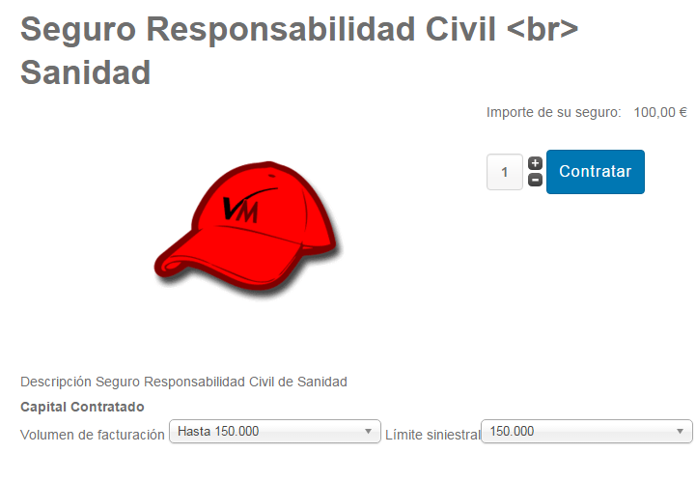

The problem arises when I go to VirtueMart custom fields within the product just imported . Although the values ​​of the custom fields in the product on the website is no data in custom fields in virtuemart product as seen in the following images:

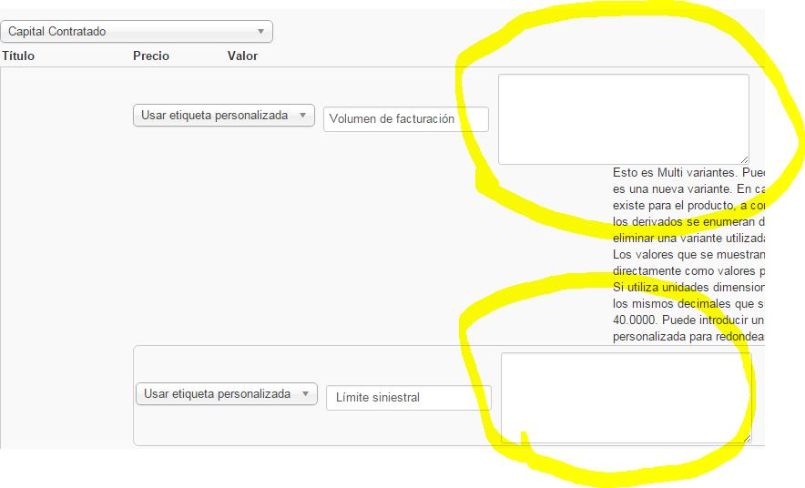

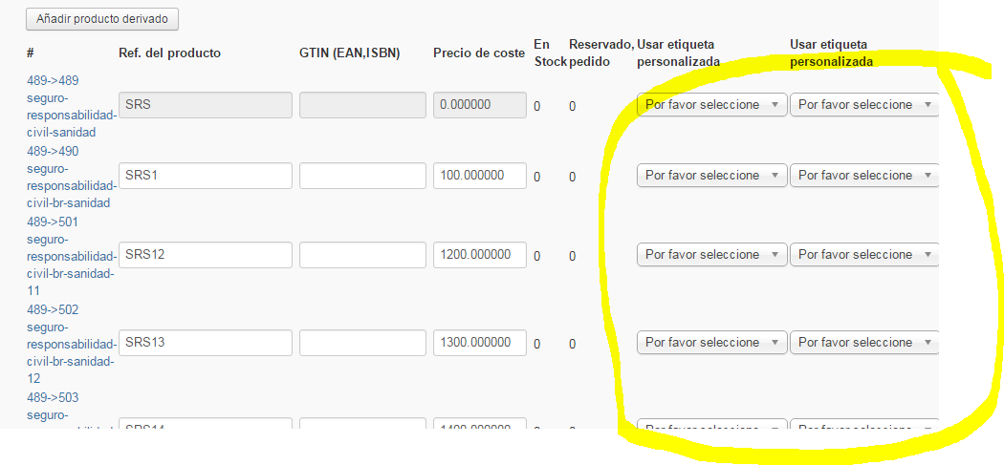

Another problem that has arisen I import a file was previously exported, like this :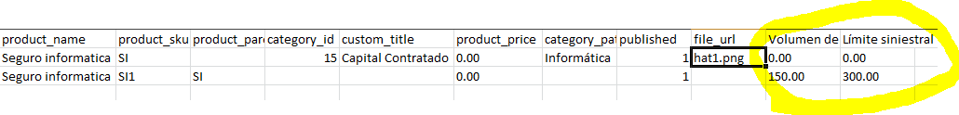
What I try to always have the same custom fields but changing other data for the other fields and exporting a product already created your custom fields and importing it again with other values ​​to create more products.
The problem arises again in the custom fields identified in the image and is that despite having created well the import template with the same fields as the table I do not enter these custom fields.
My question is : Is it necessary for each product father create the same custom fields or can create one for a parent and use them for different products ?.
Furthermore Could you use the same fields for both import and export and serve me a csv file for the two templates?

